In collaboration with:


Introduction
In this project you will have to create a system file explorer that allows the user to navigate, create directories and upload files in the same way as he would in his usual operating system. The file explorer is a tool that allows you to directly view and manipulate the files and directories associated with a path, so you must take into account from which path the user starts and which path they can access.
In the following image you can see an example that can serve as a reference:
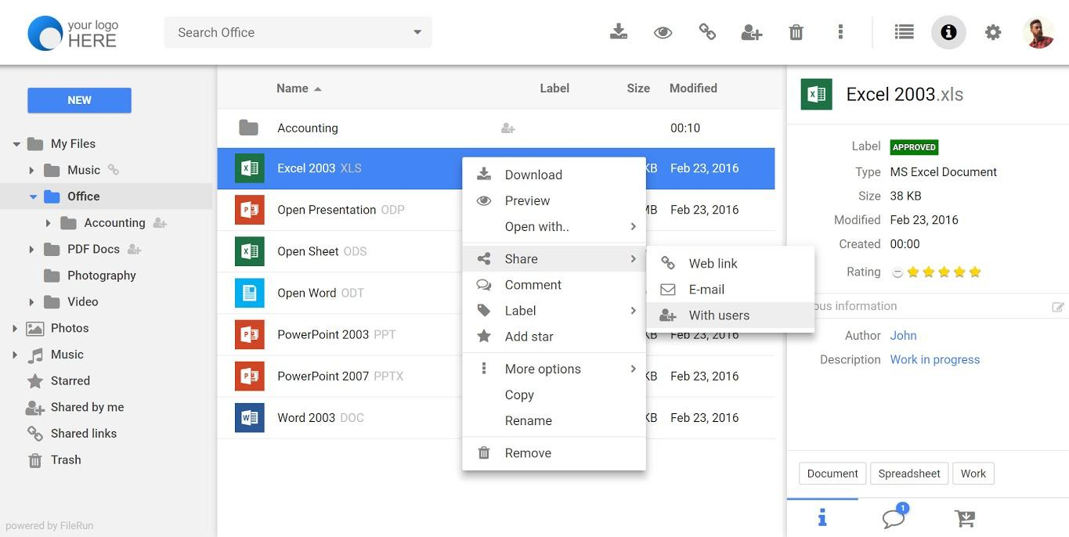

What are the main objectives in this project?
- Understand how the file system works
- Improve your knowledge in PHP
- Improve your knowledge in HTML, CSS & Javascript
- Improve your knowledge in logic and programming

1. General analysis
First of all, you will have to analyze the project requirements, with which you can get an idea of the project objectives, then design the structure of the application and analyze the actions that the user can do so that when programming you have clear which are the keys points and a previous idea of what the user interface will be like .

Step 1: Analyze the project requirements
In the first step you must analyze the requirements that the project must meet and what actions the user can do.
- Create, modify and delete directories
- Browse through directories from an initial path
  - The initial path will start from a folder inside the project repository whose name will be "root".
- Search directories and files by name
  - In the case of searching for files by name, you must also be able to specify their extension as part of the name.
- Navigate through the initial path established and all the folders created from that path. Therefore the user will not be able to see or navigate to the parent folders of the “root” folder.
- Upload a file to a directory
- See the following information of files and directories
  - Creation date
  - Last Modified Date
  - Extension (if it’s a file)
  - Size
    - If it is less than 1 MB show KB, otherwise show MB
- Show the icon of the main file extensions such as:
  - doc
  - csv
  - jpg
  - png
  - txt
  - ppt
  - odt
  - pdf
  - zip
  - rar
  - exe
  - svg
  - mp3
  - mp4
- View the uploaded images.
- Play the uploaded videos.
- Play the uploaded audios.

Step 2: Design the project structure
Before starting to develop the project you should take into account and analyze the following points:
- How will the interface be
  - You will have to design a wireframe of your application taking into account the requirements.
- What actions can be executed by the user
  - You will have to design a use case diagram
- Analyze and understand what brings more value to the user
- Analyze how you will organize the project at the level of directories and files

Step 3: Start to develop the project
Once you have all the designs and organization of your project raised, you must start developing it.

Step 4: Extra functionalities
In addition to the requirements mentioned above, you can add the following extra functionalities so that the user is able to:
- Show the information of the uploaded “.csv” files on the screen.
- Move files and directories between folders
- When deleting a file or folder, it will be moved to a specific folder called "trash", so if you want to delete it completely you must delete it from the mentioned folder.

2. Project organization
Next you will have to create a document where you can explain in detail how the current project is organized. It is important that it be updated throughout the life of the project. A PDF version is required within the project folder for the project documentation.
The document must include at least:
- Requirements documentation
- Wireframes
- Use case diagram
- Record of incidents that were detected during project execution
- Record of lessons learned

3. Development
Develop the file system explorer taking into account its architecture and respecting the frontend and backend layers. It is important that you keep in mind that the organization is very important as well as the documentation you provide to the project.

4. Requirements
- You will not be able to use global variables in PHP.
- You must use GIT
- You must use the PHP v7
- Create a clear and orderly directory structure
- Both the code and the comments must be written in English
- Use the camelCase code style to define variables and functions
- In the case of using HTML, never use inline styles
- In the case of using different programming languages ​​always define the implementation in separate terms
- Remember that it is important to divide the tasks into several sub-tasks so that in this way you can associate each particular step of the construction with a specific commit
- You should try as much as possible that the commits and the planned tasks are the same
- Delete files that are not used or are not necessary to evaluate the project

5. Deliverables
To evaluate the project you will need the following deliveries:
- Repository with code
- You must create a correctly documented README file in the root directory of the project (see guidelines in Resources)
- Project documentation in PDF format
- Presentation in PDF format explaining:
  - Comparison of the original design (Wireframe) with the final result of the project
  - Comparison of the use case diagram with the actions that the user can finally perform
  - Comparison of the original use case diagram with the final user actions
  - What lessons you’ve learned during this project
  - What problems have you encountered when developing this project?
  - How you have organized and distributed the tasks

6. Resources
- File system: https://es.wikipedia.org/wiki/Administrador_de_archivos
- PHP FileSystem W3C: https://www.w3schools.com/php/php_ref_filesystem.asp
- PHP FileSystem [Oficial]: https://www.php.net/manual/es/book.filesystem.php
- README Guidelines Example: https://gist.github.com/PurpleBooth/109311bb0361f32d87a2

6.1. Wireframes web tools
- Moqups: https://app.moqups.com/
- Draw.io: https://app.diagrams.net/
- Cacoo: https://cacoo.com/es/

